

PROJECT REPORT



COURSE REGISTRATION SYSTEM



Database Management Systems Lab



Submitted By:



Naveed Ahmad(22pwcse2165)



Jamal khan(22pwcse2203)



Omer khan(22pwcse2130)



Section B



Submitted to:



Mam Sumayyea Salahudin



Date: 04/07/2025



*Department of Computer Systems Engineering*



*University of engineering and technology, Peshawar*



# Introduction

The Course Registration System is a web-based platform that enables students to register for courses, instructors to manage their teaching schedules, and administrators to oversee academic data.

# Objectives

* Build a digital alternative to manual course registration
* Enable real-time enrollment
* Facilitate instructor and admin access to course data
* Provide a responsive user interface

# Tools & Technologies

* Backend: Laravel 11, MySQL
* Frontend: React.js, Axios
* Hosting: Netlify (frontend), Hostinger (backend)

# System Overview

* Users: Student, Instructor, Admin
* Features: Authentication, Course Enrollment, Admin Panel, RESTful API integration

# Backend Development

* Laravel Models: Student, Instructor, Course, Enrollment, Department
* RESTful APIs using api.php
* Eloquent relationships and middleware
* Tested using Postman

# Entity Relationship Diagram (ERD)

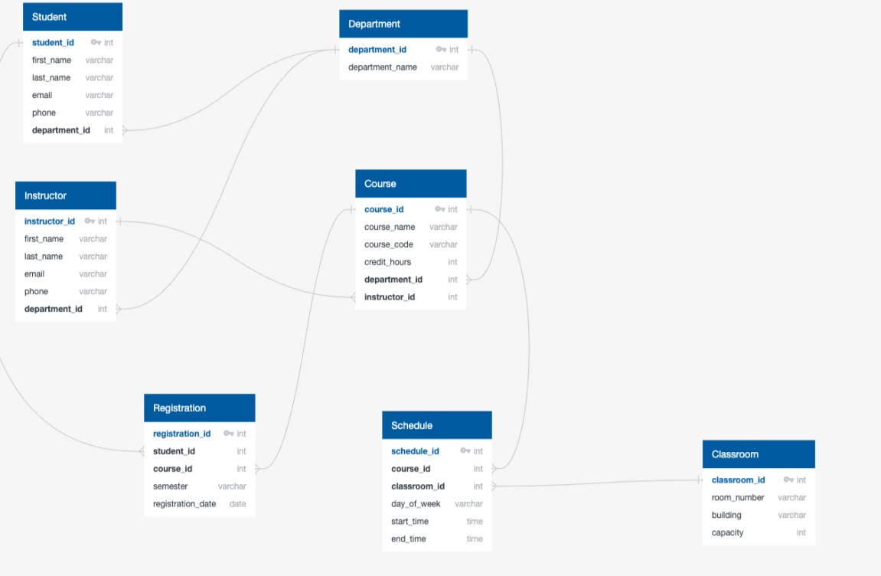

# Frontend Development

* Built using React
* Pages: Home, Login, Dashboard, Course Registration
* Axios for API requests

# Hosting & Deployment

* Frontend hosted on Netlify
* Backend hosted on Hostinger
* .env setup and CORS configured

# Challenges Faced

* CORS handling
* Hosting Laravel on Hostinger
* State management in React
* Many-to-many data handling in Laravel

# Conclusion

This project demonstrates how modern web technologies can be used to streamline academic systems, offering scalability and efficiency.

# References

* https://laravel.com/docs
* https://react.dev
* [https://docs.netlify.com](https://docs.netlify.com/)
* [https://support.hostinger.com](https://support.hostinger.com/)
* [https://chat.openai.com](https://chat.openai.com/)

screenshot:

